Project Overview: Static Website (My Resume) Hosting on AWS

View on Web: https://hardikaws.online

Objective:
To create a professional online presence by hosting a resume website using AWS services, demonstrating proficiency in cloud computing and web technologies.

Services Used:
AWS S3
AWS Route 53
AWS CloudFront
AWS ACM
GoDaddy

Architecture Diagram:

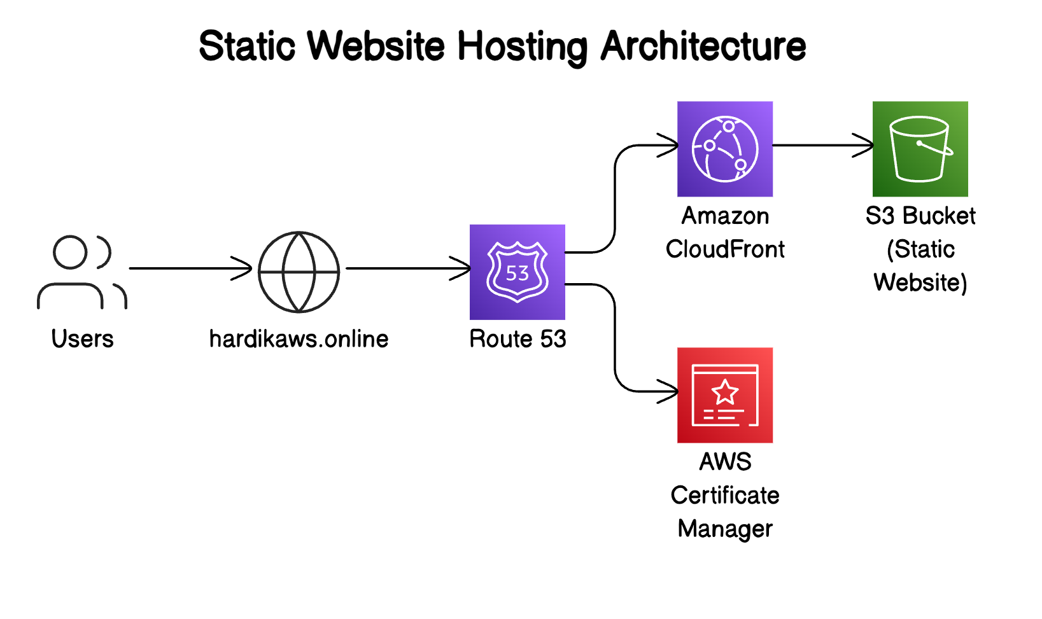

Implementation Steps:
- Web Development:
- Developed a responsive resume website using HTML, CSS, and JavaScript.
- Included a professional headshot image to enhance the visual appeal of the site.
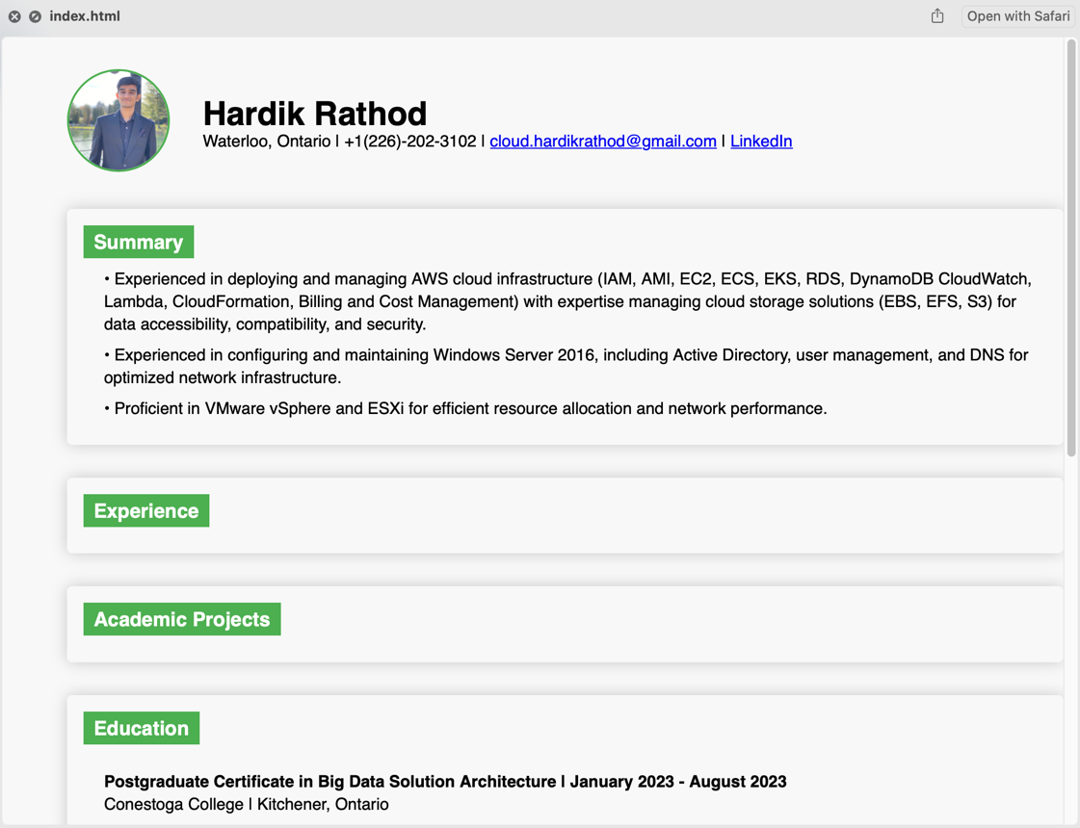

- AWS S3 Configuration:
- Created an Amazon S3 bucket and configured it for static website hosting with public access.
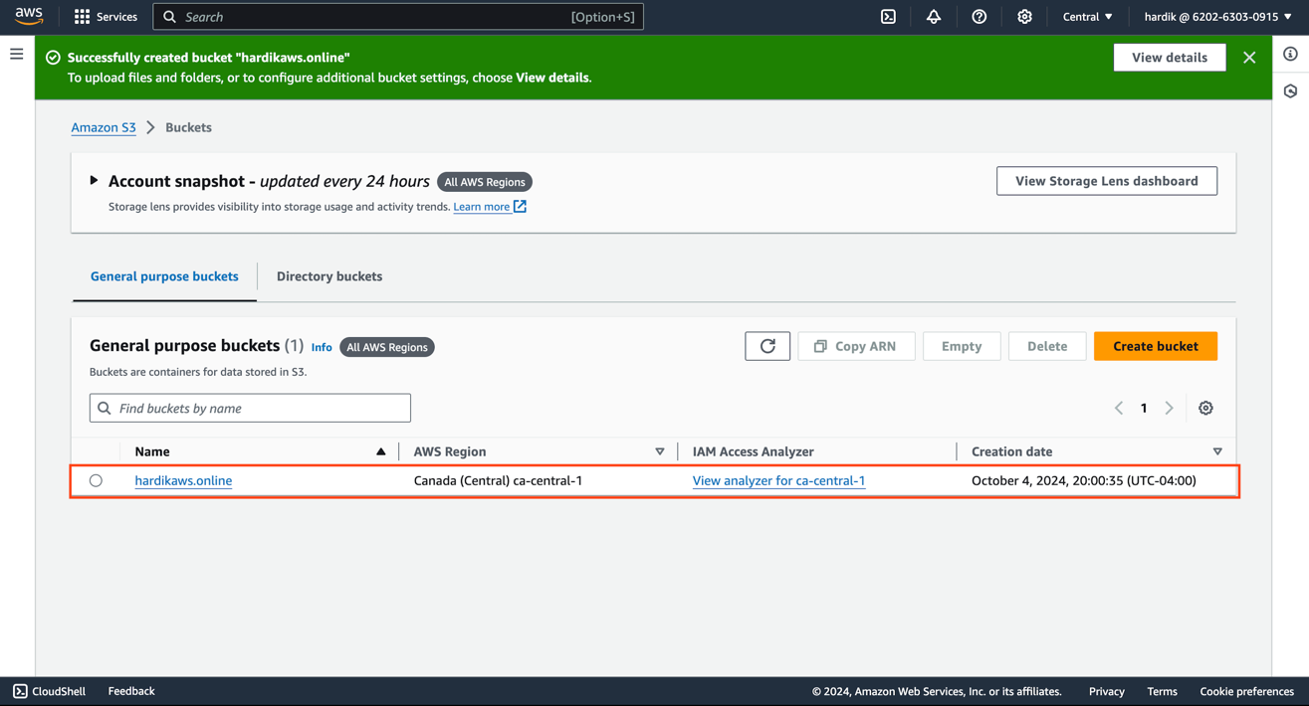
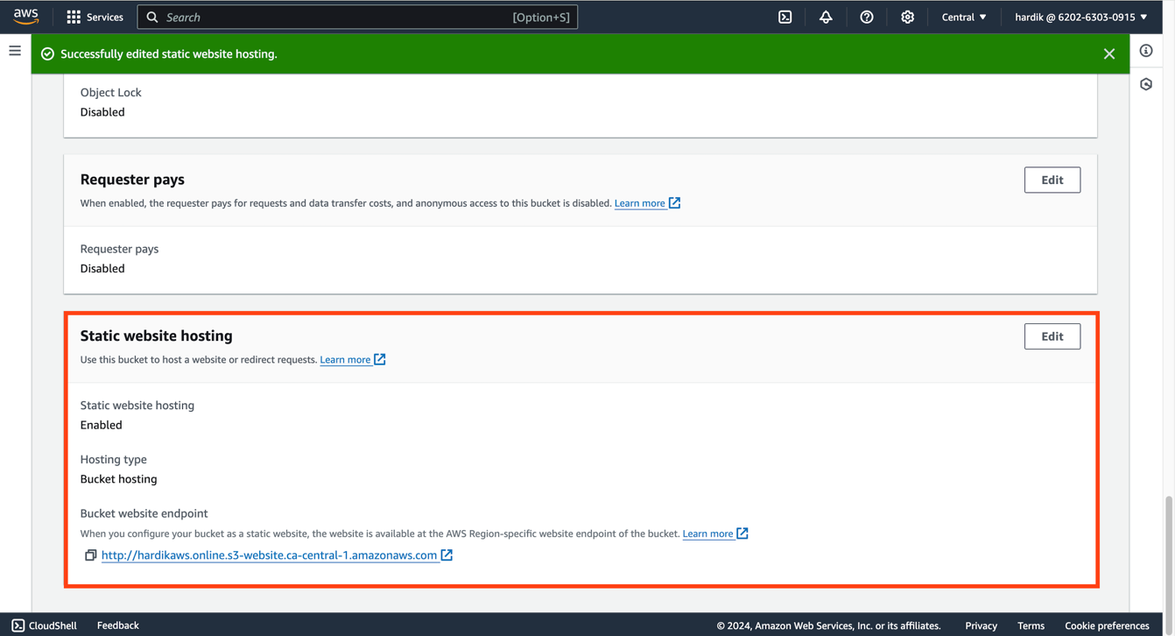

- Uploaded the HTML, CSS, JavaScript files, and the headshot image to the S3 bucket.
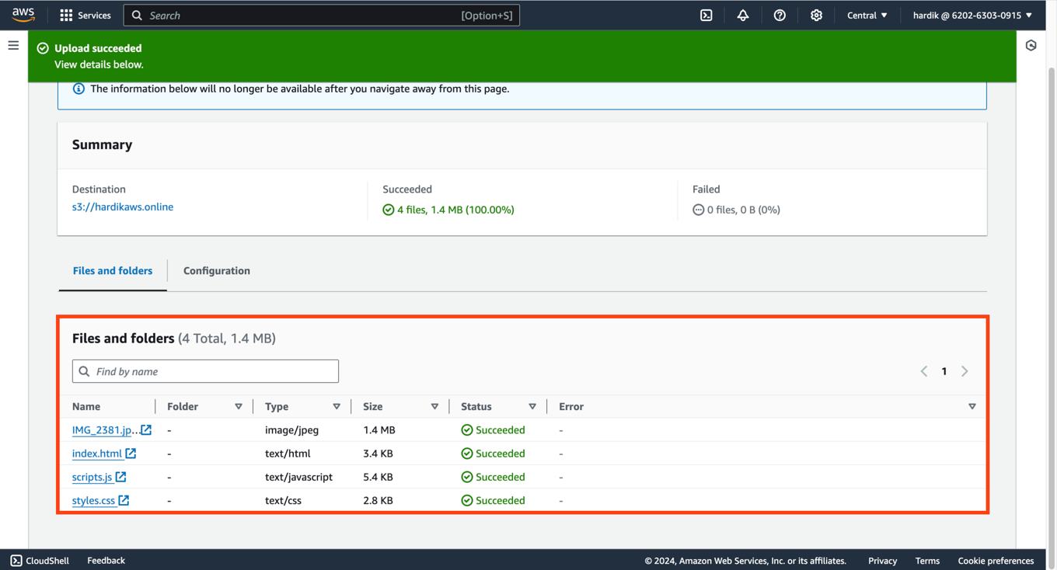

- Implemented a bucket policy to enable public read access to the uploaded files.
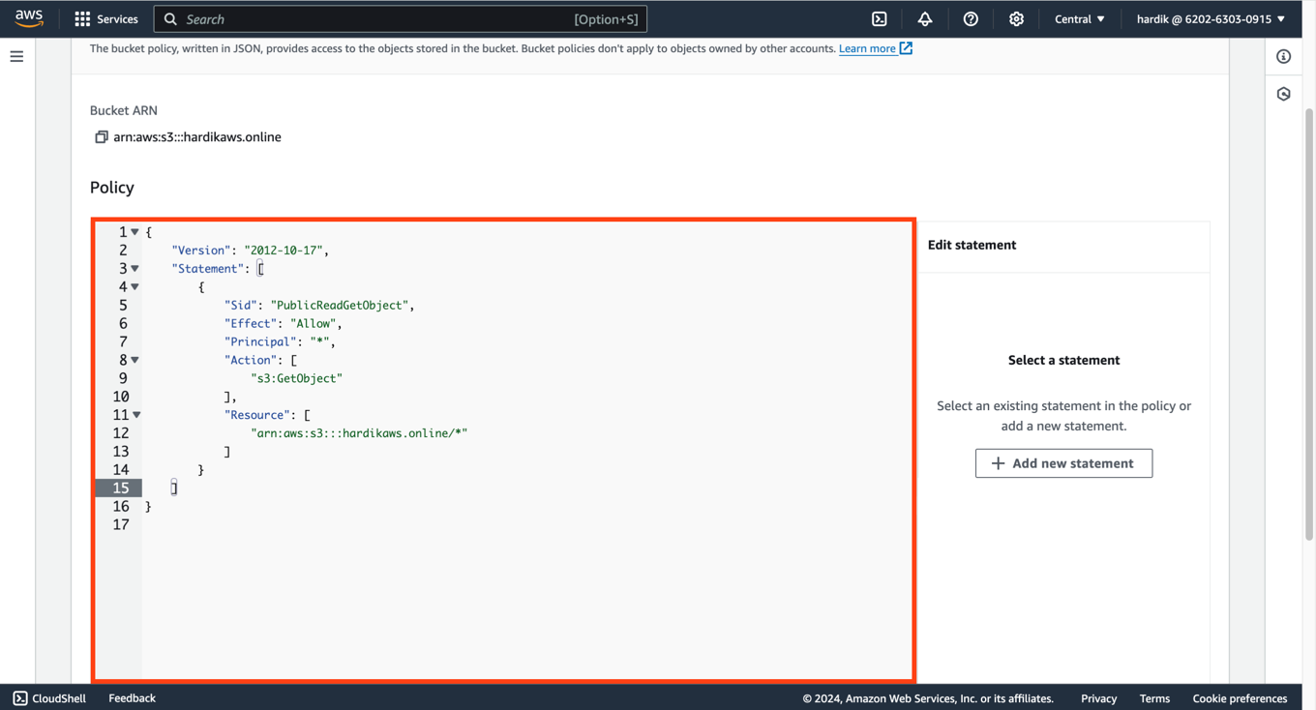

- Domain Registration:
- Registered a custom domain name through GoDaddy.
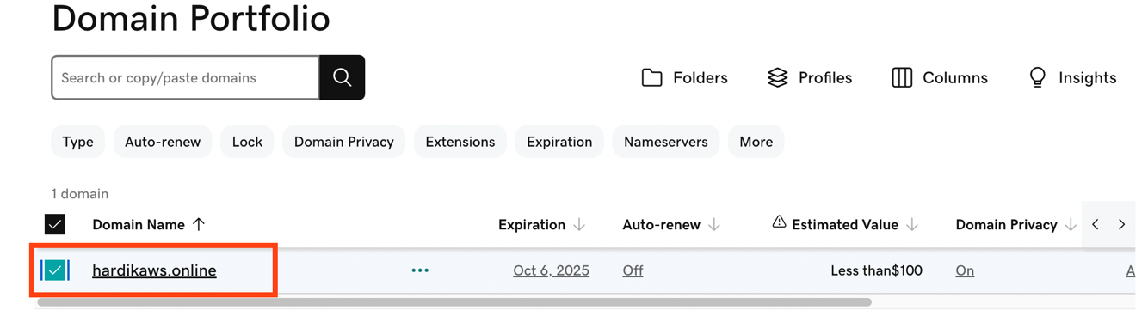

- Established a hosted zone in AWS Route 53 to integrate the third-party domain with AWS.
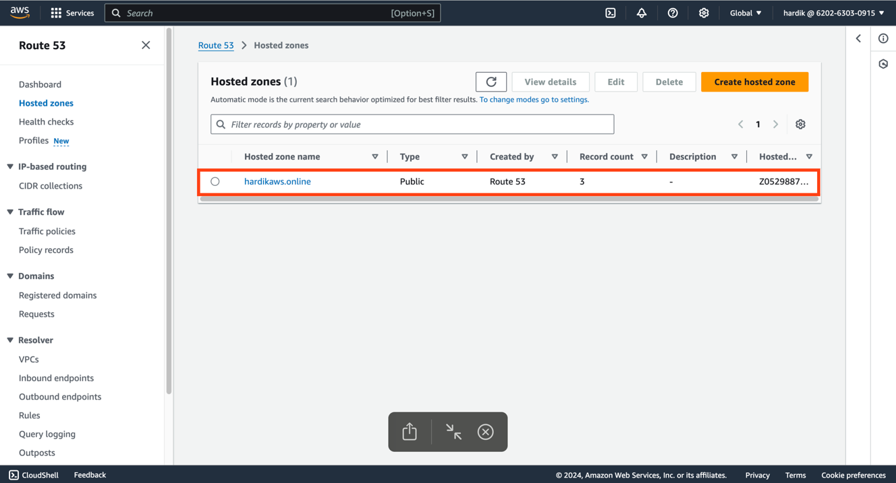

- DNS Configuration:
- Created DNS records to point to the S3 website endpoint.
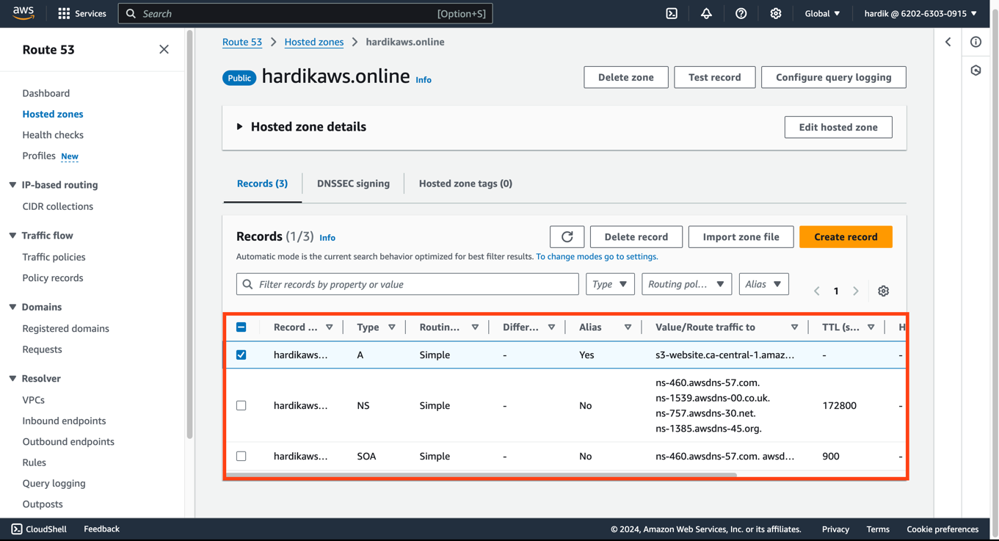
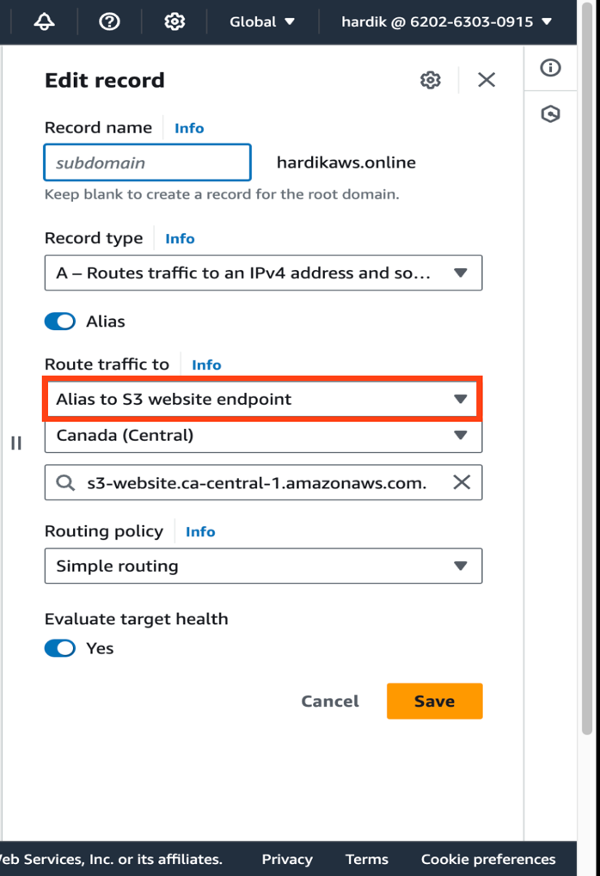
- Updated the name servers in the GoDaddy domain settings to use AWS name servers, ensuring proper domain management.
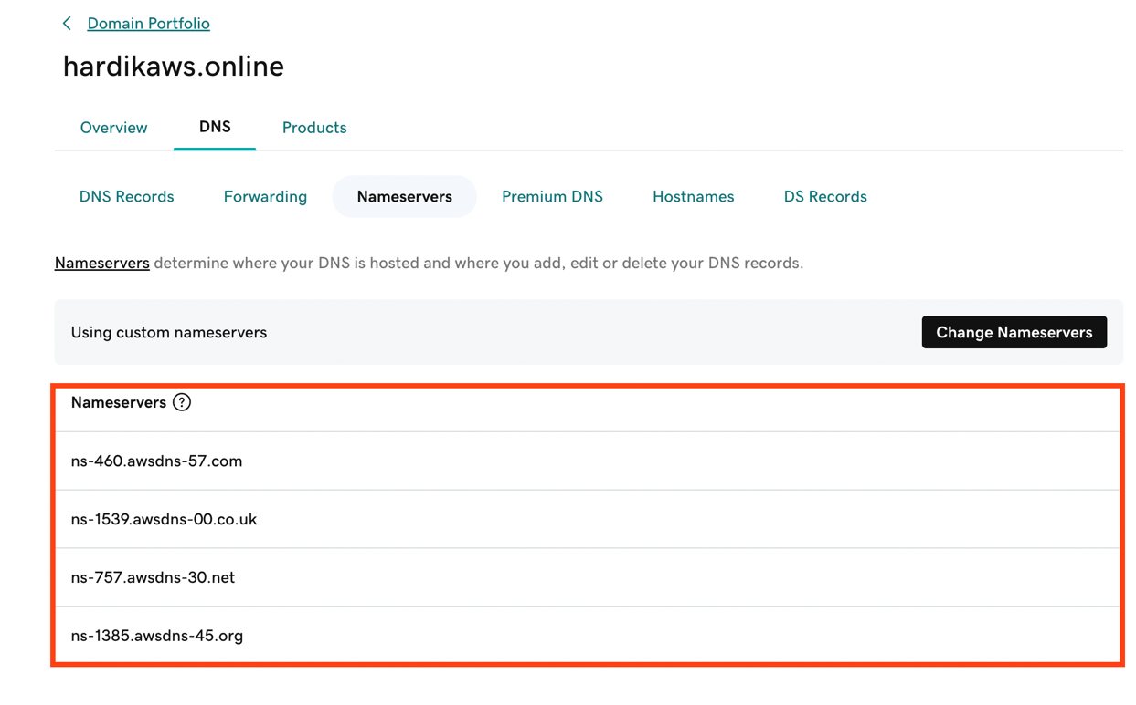

- Accessed the website which is not secured yet.
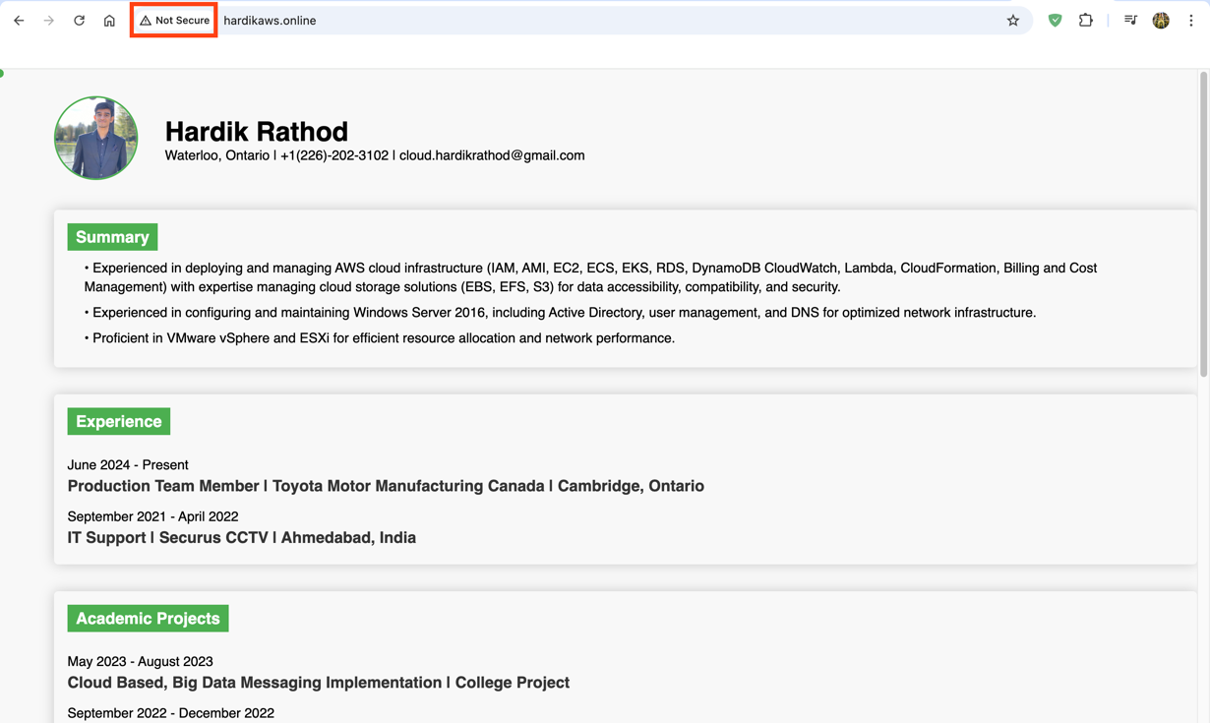

- SSL Certificate Implementation:
- Obtained an SSL certificate for secure HTTPS connections using AWS Certificate Manager.
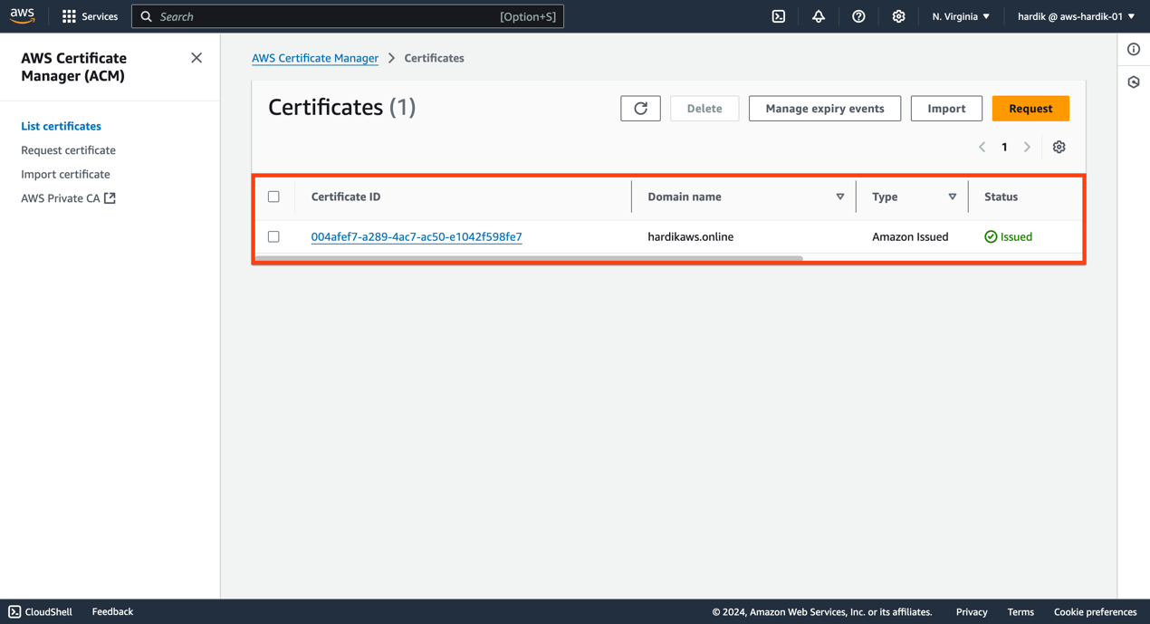

- Validated the SSL certificate using the DNS method for enhanced security.
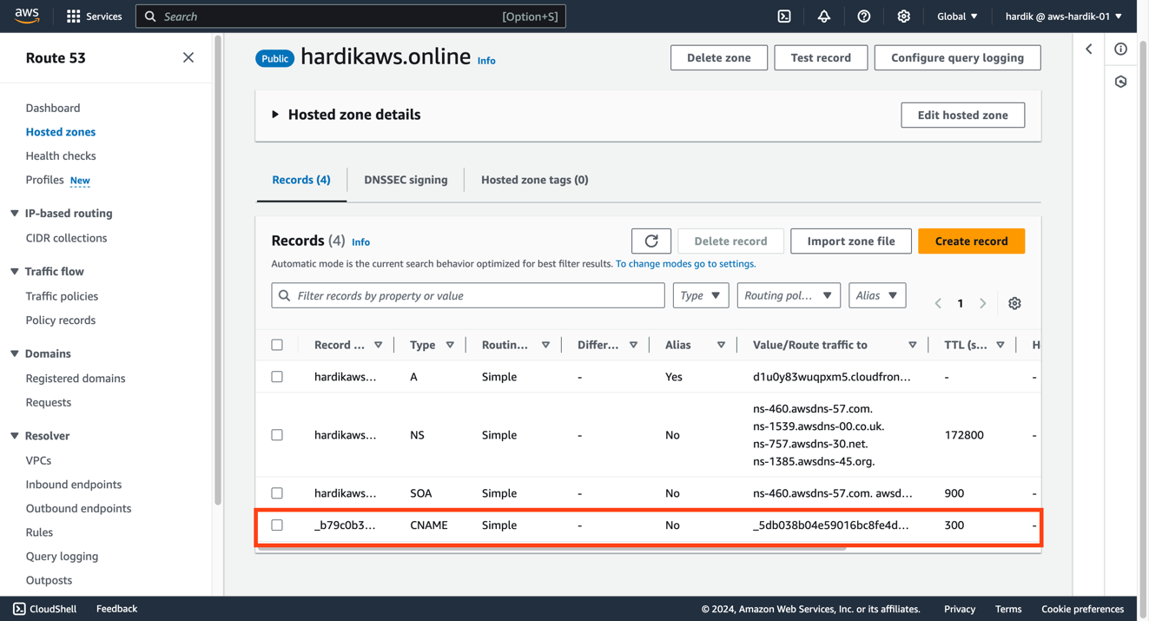

- CloudFront Distribution:
- Created an Amazon CloudFront distribution to serve the S3 website.
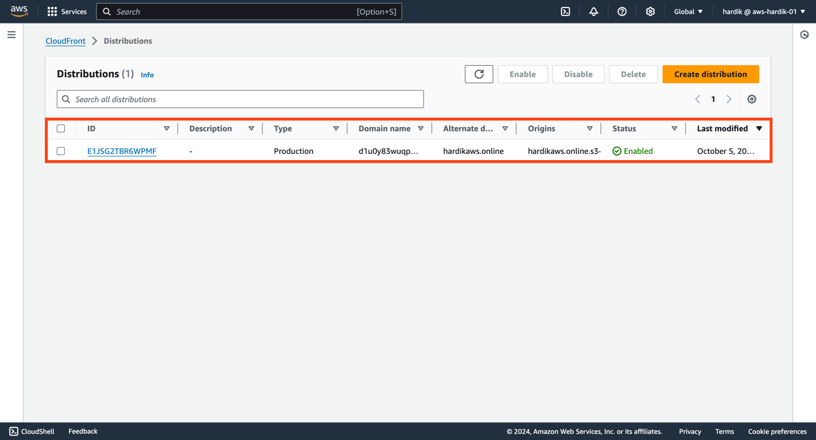

- Configured CloudFront to redirect all HTTP requests to HTTPS, ensuring secure access.
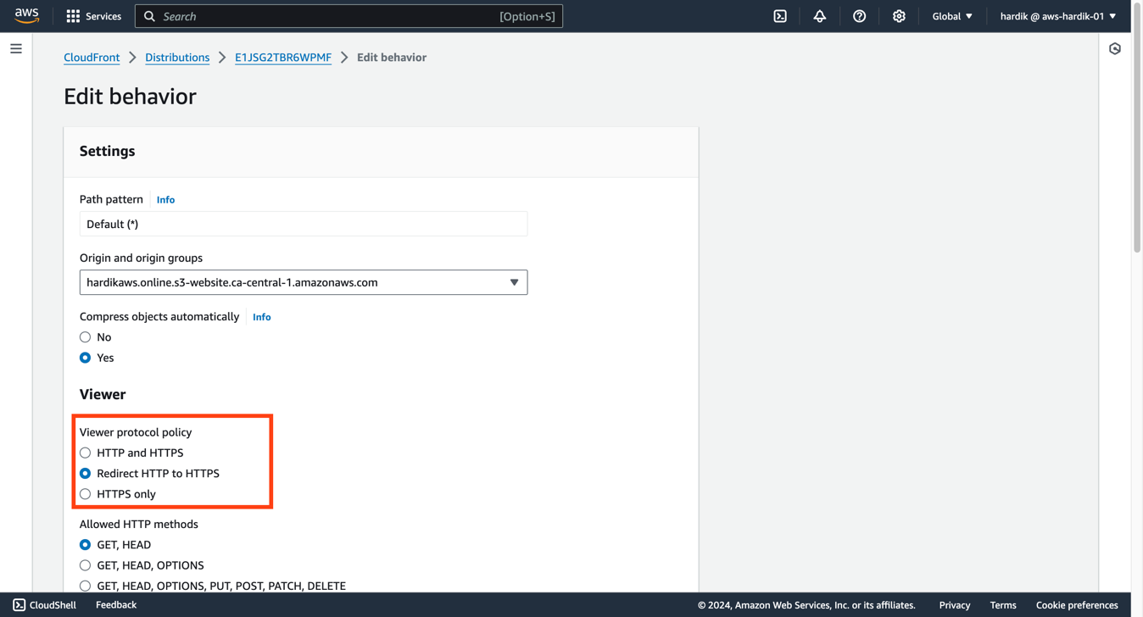

- Attached the SSL certificate to the CloudFront distribution for encrypted data transfer.
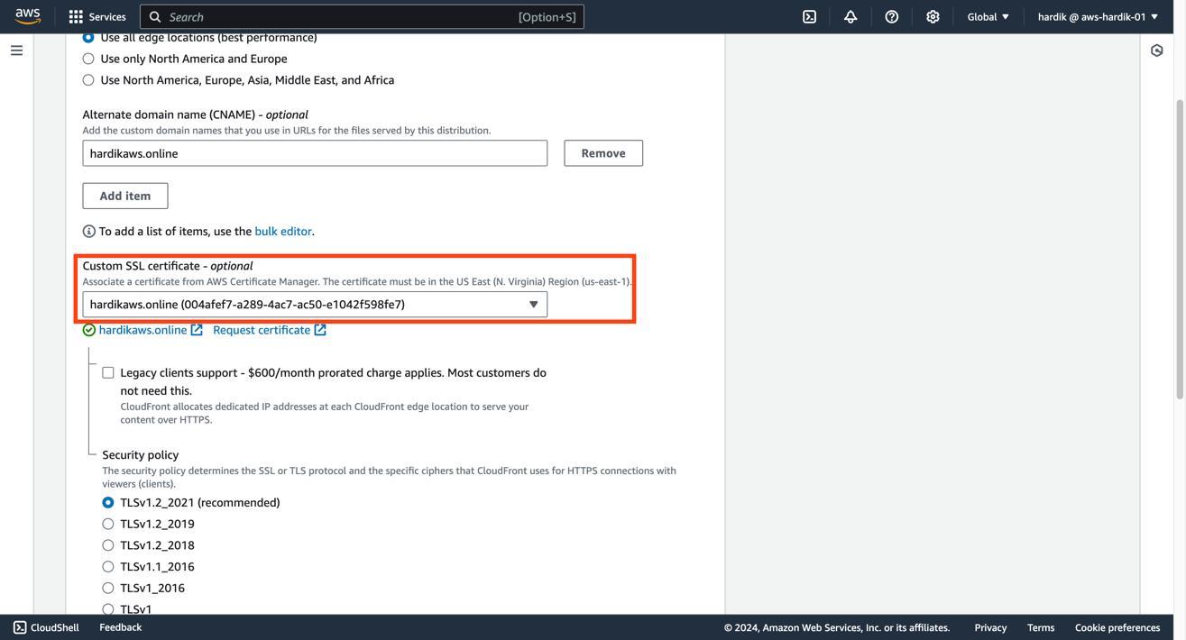

- Set the S3 website endpoint as the origin for the CloudFront distribution.
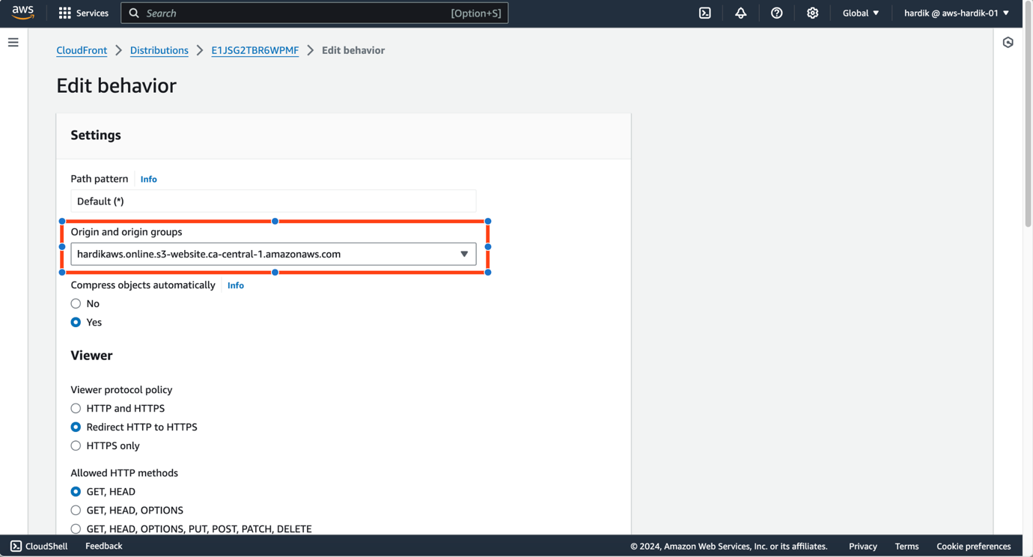

- Final DNS Configuration:
- Modified the alias configuration in Route 53 to utilize the CloudFront distribution instead of the S3 website endpoint for optimized performance and security.
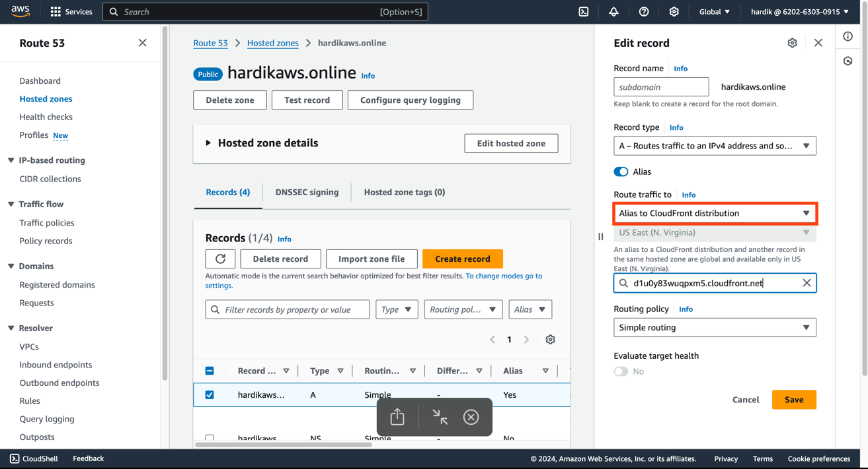

- Accessed the website which is secured now with the help of CloudFront.
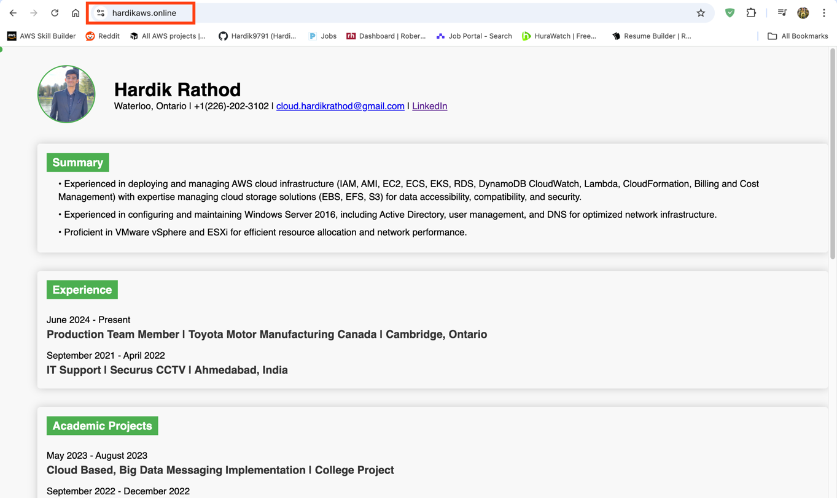

Key Features:

- Deployment of Web Applications: Successfully deployed web applications in the cloud environment, ensuring high availability and scalability.

- AWS Service Integration: Integrated various AWS services, enhancing application functionality and performance.

- Security Best Practices: Implemented security best practices, ensuring data protection and compliance with industry standards.

- Efficient Resource Management: Managed cloud resources efficiently, optimizing costs while maintaining performance.

Summary:

This project highlights my ability to deploy and manage web applications in the cloud, showcasing skills in AWS service integration, security best practices, and efficient resource management.

